Letter Tiles for Reading Simplified Switch It
These letters were initiated before Reading Simplified Revised the Switch It Lists in 2020 and are now revised to match.
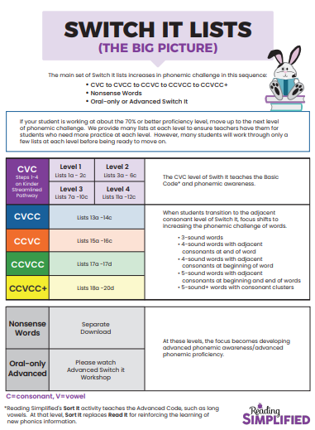
1-10 PK/K (Separate Reading Simplified List; included here)
11-14 1st Grade (not in Reading Simplified List; included here)
15-21 Level 1 Lists 1a-2c
22-35 Level 2 Lists 3a-6c
36-49 Level 3 Lists 7a-10c
50-56 Level 4 Lists 11a-2c
57-63 Lists 13a-14c CVCC
64-70 Lists 15a-16c CCVC
71-74 Lists 17a-17d CCVCC
75-77h Lists 18a-20d CCVCC+ (77a-77h were added in revision; included here)
78-91 Lists 21a-21d Nonsense Words
The 1-91 Numbering System
Correlating to Reading Simplified List
Here are examples of how the Reading Simplified Lists were renumbered.
Note that the List Numbers changed. The old List Numbers will be in italics and the new List Numbers included.
Example:
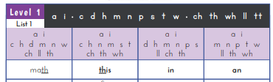 | is now | 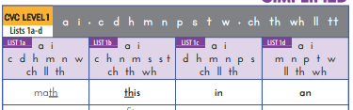

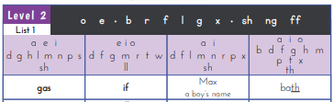 | is now | 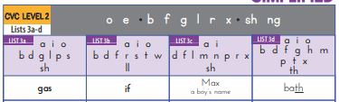
Sherwood’s #15 is where the Reading Simplified List begins.
Kindergarten Primary Penmanship is the font used for the Letter Tiles following the PK/K (P1) and 1st Grade Lists.

Storage for
Switch It Letter Tiles:
Four Sets of Tiles Per Switch It List
in Half-Envelopes in Three Kleenex Boxes
I took legal size envelopes, sealed them, and cut them in half.
Each half-envelope contains four sets of Letter Tiles per Switch It List.
Clarifications:
41 Level 3 List 2 is now: 41 CVC Level 3 List 8b.
71 CCVCC List 1 is now: 71 CCVCC List 17a.
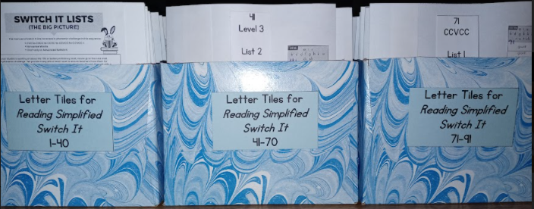

This shows the contents of the envelope for Switch It CVC Level 1 List 1a (Sherwood’s #15 Level 1 List 1 Col. a).
The lists of words are glued onto the envelopes.
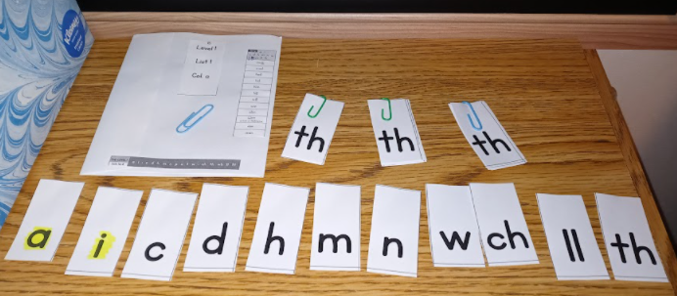
PS I highlighted vowels in yellow because classroom teachers use IMSE whose vowels are on yellow cards.

#1-9: Switch It List – PK/K Before Level 1 List 1 [(Pages 28-36 in PK/K Grade Guide) SEPARATE READING SIMPLIFIED LIST]
P-1a  1  s a t m p  sat  mat map  sap  tap | P-1b  2  a d m n p s t  sat  sad  sap nap  tap  tad mad  New  n d | P-1c  3  a c d h m n p s t  sad had  hat  cat  can  an  pan man mad had  New  c h | P-1d  4  a c d h m n p t th  an  man math mad had  hat that than can  cap nap  New  th | P-1e  5  a i c d f n p s t  cat  sat  sit  sip  sap  nap  nip  tip  tap  tad  fad  fat  fit  New  i f | P-2a  6  a i f m n ss t th tt w ll  that  fat  fit  it  wit with win • math mass miss mitt mill  New  w ss tt ll | P-2b  7  a i d f h m n p w th ss ll  pin  pan path math mad had  hid  hiss  hill  mill  fill  will  Review | P-2c  8  a i d h m n p s t wh ck  Tim whim whip  sip  hip  hid  had hack whack pack pick pin  New  wh ck | P-2e  9  a i c ch d l m p r tch wh  whim which rich  rip  chip chap lap latch* catch  New  ch tch r  *Remove ch and reveal tch

#10-14: Switch It List – 1st Grade [Before Level 1 List 1 (Pages 3-7 in 1st Grade Guide) NOT IN READING SIMPLIFIED LIST]
(10)  e t wh i d f a n r ch u p  rich which whip  tip  tin  ten when whet whit whip dip  din Dan fan  fun  New  wh | (11)  m a f u e b n p i g s t j  jump bump bum gum gut gust must mist fist  fast past pest best bent | (12)  a i l ck m d u f s tt o p e  Matt mitt mutt muck duck luck lick slick flick fleck flock flop flap  New  ck | (13)  a i h th m d u n t wh t o p e r w  when then them hem them then than  ran  run  runt  punt pent went wend*  *go in a specified direction, typically slowly or by an indirect route.  New  th | (14)  a i f t n t o p e w x sh l  text next net  not nosh posh pot shot shop ship lip  flip  flap flat  fat  fit  fish wish  New  sh

1  PK/K  Pre  Level 1  Level P1  List P-1a  Separate RS List  Included Above | s | a | t | m | p
2  PK/K  Pre  Level 1  Level P1  List P-1b  Separate RS List  Included Above | a | d | m | n | p | s | t
3  PK/K  Pre  Level 1  Level P1  List P-1c  Separate RS List  Included Above | a | c | d | h | m | n | p
 | s | t |  |  |  | th | t
4  PK/K  Pre  Level 1  Level P1  List P-1d  Separate RS List  Included Above | a | c | d | h | m | n | p

5  PK/K  Pre  Level 1  Level P1  List P-1e  Separate RS List  Included Above | a | i | c | d | f | n | p
 | s | t
6  PK/K  Pre  Level 1  Level P1  List P-2a  Separate RS List  Included Above | a | i | f | m | n | ss | t
 | th | tt | w | ll
7  PK/K  Pre  Level 1  Level P1  List P-2b  Separate RS List  Included Above | a | i | d | f | h | m | n

 |  | p | w | th | ss | ll
8  PK/K  Pre  Level 1  Level P1  List P-2c  Separate RS List  Included Above | a | i | d | h | m | n | p
wh |  | s | t | ck
9  PK/K  Pre  Level 1  Level P1  List P-2d  Separate RS List  Included Above | a | i | c | ch | d | l | m
wh |  | tch |  | p | r

10  1st Grade  Pre  Level 1  In RS 1st Grade Packet  Not in RS List | e |  | t |  | i |  | d | f | a | n
wh |  |  | r |  | ch |  | u | p
11  1st Grade  Pre  Level 1  In RS 1st Grade Packet  Not in RS List |  | m |  | a |  | f | u | e | b | n
 |  | p |  | i |  | g | s | t | j
12  1st Grade  Pre  Level 1  In RS 1st Grade Packet  Not in RS List |  | a |  | i |  | l | ck | m | d | u

 | f | s |  |  | tt |  |  | o |  | p |  | e
13  1st Grade  Pre  Level 1  In RS 1st Grade Packet  Not in RS List | a | i |  |  | h |  |  | th |  | m |  | d |  | u
wh t |  | n |  |  | t |  |  | o |  | p |  | e |  | r
w | 14  1st Grade  Pre  Level 1  In RS 1st Grade Packet  Not in RS List |  | a |  |  | i |  | f |  | t |  | n |  | o
 |  |  |  | p |  |  | e |  | w |  | x |  | sh | l

15  Level 1  List 1  Col. a  CVC Level 1  List 1a  RS List Starts Here | a |  | i |  | c |  | h |  | d |  | m |  | n
 | w |  | ch |  | ll |  | th
16  Level 1  List 1  Col. b  CVC Level 1  List 1b | a |  | i |  | c |  | h |  | n |  | m |  | s
wh |  |  | t |  | ch |  | th |  | s
17  Level 1  List 1  Col. c  CVC Level 1  List 1c |  | a |  | i |  | d |  | h |  | m |  | n |  | p

 | s | ll | ch | th
18  Level 1  List 1  Col. d  CVC Level 1  List 1d | a | i | m | n | p | t | w
wh |  | ll | th
19  Level 1  List 2  Col. a  CVC Level 1  List 2a | a | i | m | n | p | t | ch
 | ss | th

20  Level 1  List 2  Col. b  CVC Level 1  List 2b | a | i | c | h | m | p | t
 | ll | th | ss | tt
21  Level 1  List 2  Col. c  CVC Level 1  List 2c | a | i | h | d | d | m | p
 | s | t | ch | ll | ss
22  Level 2  List 1  Col. a  CVC Level 2  List 3a  Delete: e h m n  Add: o b | a | e | i | d | g | h | l

 | m | n | p | s | sh | o | b
23  Level 2  List 1  Col. b  CVC Level 2 List 3b  Delete: e b g m  Add: a b s | e | i | o | d | f | g | m
 | r | t | w | ll | a | b | s
24  Level 2  List 1  Col. c  CVC Level 2 List 3c | a | i | d | f | l | m | n
 | r | p | x | sh

25  Level 2  List 1  Col. d  CVC Level 2 List 3d | a | i | o | b | d | f | g
 | h | m | p | t | x | th
26  Level 2  List 2  Col. a  CVC Level 2 List 4a | i | o | c | d | l | m | m
 | p | r | t | ng | sh
27  Level 2  List 2  Col. b  CVC Level 2 List 4b | e | o | b | g | n | p | r

 | t | ff | ss
28  Level 2  List 2  Col. c  CVC Level 2 List 4c | a | i | f | g | n | r | s
 | w | x | ch | ng | sh
29  Level 2  List 3  Col. a  CVC Level 2 List 5a | a | e | i | o | b | f | t
 | w | x | dd | ll

30  Level 2  List 3  Col. b  CVC Level 2 List 5b | a | e | i | o | b | f | g
 | n | r | t | x | ll
31  Level 2  List 3  Col. c  CVC Level 2 List 5c | a | e | o | c | b | d | l
 | s | t | ll | ng | ss
32  Level 2  List 3  Col. d  CVC Level 2 List 5d | a | e | o | d | f | g | h

 | l | p | r | t | ng | wr
33  Level 2  List 4  Col. a  CVC Level 2 List 6a | a | e | i | o | b | l | g
 | r | t | w | x | gu | ss
34  Level 2  List 4  Col. b  CVC Level 2 List 6b | a | e | i | o | b | d | g
 | l | s | t | ll | sh

35  Level 2  List 4  Col. c  CVC Level 2 List 6c | a | e | i | b | h | g | m
 | n | p | r | ng | th | wh
36  Level 3  List 1  Col. a  CVC Level 3 List 7a | o | u | b | d | g | j | s
 | t | ck | th | G
37  Level 3  List 1  Col. b  CVC Level 3 List 7b | a | o | u | b | c | f | j

 | n | s | t | v | ch
38  Level 3  List 1  Col. c  CVC Level 3 List 7c | i | o | u | g | h | j | k
 | m | t | ck | ss
39  Level 3  List 1  Col. d  CVC Level 3 List 7d | a | o | u | b | h | r | s
 | t | ck | ng | sh

40  Level 3  List 2  Col. a  CVC Level 3 List 8a | a | i | u | g | m | n | p
 | r | s | ch | ck | qu | th
41  Level 3  List 2  Col. b  CVC Level 3 List 8b | a | i | u | b | d | d | f
 | g | h | k | w | ck | sh
42  Level 3  List 2  Col. c  CVC Level 3 List 8c | a | e | u | g | h | j | n

 | p | t | v | x | ff
43  Level 3  List 3  Col. a  CVC Level 3 List 9a | a | e | i | u | f | k | n
 | r | t | ng | ss
44  Level 3  List 3  Col. b  CVC Level 3 List 9b | a | e | o | u | b | c | j
 | s | t | v | ck

45  Level 3  List 3  Col. c  CVC Level 3 List 9c | a | e | i | u | b | d | j
 | l | m | n | s | ch | ck
46  Level 3  List 3  Col. d  CVC Level 3 List 9d | a | i | o | u | b | p | p
 | t | qu | th | ck
47  Level 3  List 4  Col. a  CVC Level 3 List a | a | i | o | u | b | c | j

 | k | p | p | ck | ng | sh
48  Level 3  List 4  Col. b  CVC Level 3  List 10b | e | i | o | u | d | g | h
 | k | l | m | t | ch | ck | qu
49  Level 3  List 4  Col. c  CVC Level 3 List 10c | e | i | o | u | g | n | m
 | p | s | t | ck | sh | sh

50  Level 4  List 1  Col. a  CVC Level 4  List 11a | a | i | o | ar | d | k | p
 | t | z | ch | sh
51  Level 4  List 1  Col. b  CVC Level 4  List 11b | a | e | ar | or | c | b | k
tch |  | m | n | p | s | t | y
52  Level 4  List 1  Col. c  CVC Level 4  List 11c | a | ar | or | c | f | k | m

 | n | t | y | th
53  Level 4  List 1  Col. d  CVC Level 4  List 11d | a | i | or | ar | c | f | n
 | o | s | t | ch | th
54  Level 4  List 2  Col. a  CVC Level 4  List 12a | a | e | i | ar | h | d | n
 | p | y | ll | sh | tch

55  Level 4  List 2  Col. b  CVC Level 4  List 12b | a | i | u | ar | d | h | g
 | k | m | w | z | ch | ng
56  Level 4  List 2  Col. c  CVC Level 4  List 12c | u | ar | or | h | f | m | p
 | t | y | ck | sh
57  CVCC  List 1  Col. a  CVCC  List 13a | a | e | i | b | d | f | g

 | h | l | n | p | s | t
58  CVCC  List 1  Col. b  CVCC  List 13b | a | e | u | h | j | l | m
 | n | p | s | t | t | x
59  CVCC  List 1  Col. c  CVCC  List 13c | a | e | c | d | f | h | k
 | l | m | p | s | t

60  CVCC  List 1  Col. d  CVCC  List 13d | a | e | u | b | f | k | l
 | n | p | r | s | t | w
61  CVCC  List 2  Col. a  CVCC  List 14a | e | i | f | k | l | m | n
 | p | s | t | w
62  CVCC  List 2  Col. b  CVCC  List 14b | a | e | o | u | c | f | j

 | l | m | n | r | s | t
63  CVCC  List 2  Col. c  CVCC  List 14c | a | e | i | b | d | k | l
 | n | w | ng | th
64  CCVC  List 1  Col. a  CCVC  List 15a | a | i | o | c | d | f | l
 | p | r | t | ll | ss

65  CCVC  List 1  Col. b  CCVC  List 15b | a | i | u | l | m | n | p
 | r | s | t | w | ck | ng
66  CCVC  List 1  Col. c  CCVC  List 15c | e | i | o | b | k | l | n
 | p | r | s | t | ck | ng
67  CCVC  List 1  Col. d  CCVC  List 15d | a | e | i | c | d | f | g

 | l | n | p | r | sh
68  CCVC  List 2  Col. a  CCVC  List 16a | e | i | o | c | f | l | m
 | p | p | s | t | ck | ll
69  CCVC  List 2  Col. b  CCVC  List 16b | a | i | o | u | b | c | g
 | l | p | r | s | t | ck

70  CCVC  List 2  Col. c  CCVC  List 16c | a | e | o | b | c | d | g
 | l | p | p | r | ck | ss
71  CCVCC  List 1  Col. a  CCVCC  List 17a | a | i | u | b | d | g | k
 | k | l | n | r | s | t | ch
72  CCVCC  List 1  Col. b  CCVCC  List 17b | a | i | o | u | c | l | m

 | p | s | t | tch
73  CCVCC  List 1  Col. c  CCVCC  List 17c | a | i | d | k | l | n | p
 | r | s | s | t | ck
74  CCVCC  List 1  Col. d  CCVCC  List 17d | a | e | u | o | b | c | d
 | l | n | r | ch | ck | tch

75  CCVCC  List 2  Col. a  CCVCC+  List 18a | a | i | u | b | c | f | l
 | n | k | r | ng
76  CCVCC  List 2  Col. b  CCVCC+  List 18b | a | u | l | m | p | p | r
 | s | t | sh
77  CCVCC  List 2  Col. c  CCVCC+  List 18c | a | i | d | g | l | k | n

77a  CCVCC+  List 19a  (Revised 2020  Page 19) | a | i | o | u | l | m | n
 | p | s | s | t
77b  CCVCC+  List 19b  (Revised 2020  Page 19) | a | e | u | b | d | g | l
 | n | r | s | t | ch

77c  CCVCC+  List 19c  (Revised 2020  Page 19) | a | e | u | b | c | g | d
 | l | n | r | s | t | t
77d  CCVCC+  List 19d  (Revised 2020  Page 19) | a | e | i | d | n | p | r
 | s | s | t

77e  CCVCC+  List 20a  (Revised 2020  Page 20) | a | e | i | o | u | b | d
 | l | n | p | s | s | t | t
77f  CCVCC+  List 20b  (Revised 2020  Page 20) | a | e | i | o | u | c | d
 | l | m | p | p | r | s | t

77g  CCVCC+  List 20c  (Revised 2020  Page 20) | a | i | u | c | l | m | p
 | r | r | p | s | s | sh
77h  CCVCC+  List 20d  (Revised 2020  Page 20) | a | i | u | b | k | k | l
 | n | p | r | s | t | ck

77 cont.  CCVCC  List 2  Col. c  CCVCC+  List 18c | p | r | s | t | ng
78  CCVCC  nonsense  List 1 Col. a  CCVCC  Nonsense mostly  List 21a  Col. a | a | i | o | u | b | g | l
 | n | r | s | t | t
79  CCVCC  nonsense  List 1 Col. b  CCVCC  Nonsense mostly  List 21a  Col. b | a | i | o | u | c | d | f
 | l | p | r | s | t

80  CCVCC  nonsense  List 1 Col. c  CCVCC  Nonsense mostly  List 21a  Col. c | a | i | o | u | c | f | g
 | k | l | m | p | r | s
81  CCVCC  nonsense  List 1 Col. d  CCVCC  Nonsense mostly  List 21a  Col. d | a | e | i | o | u | b | c
l | m | p | p | r | s | t | t
82  CCVCC  nonsense  List 2 Col. a CCVCC  Nonsense mostly  List 21b  Col. a | a | i | o | u | b | c | d

 | d | l | n | r | w | t | t
83  CCVCC  nonsense  List 2 Col. b  CCVCC  Nonsense mostly  List 21b  Col. b | a | e | i | o | u | b | c
 | d | f | l | n | r | t
84  CCVCC  nonsense  List 2 Col. c  CCVCC  Nonsense mostly  List 21b  Col. c | a | i | o | u | g | k | l
 | m | p | p | s | t

85  CCVCC  nonsense  List 3 Col. a  CCVCC  Nonsense mostly  List 21c  Col. a | a | e | i | o | u | c | g
 | l | m | p | p | r | s | sh
86  CCVCC  nonsense  List 3 Col. b  CCVCC  Nonsense mostly  List 21c  Col. b | a | e | i | o | u | d | k
 | l | n | p | r | s | t
87  CCVCC  nonsense  List 3 Col. c  CCVCC  Nonsense mostly  List 21c  Col. c | a | e | i | o | u | k | n

 | p | r | s | s | t | t | ng
88  CCVCC  nonsense  List 4 Col. a  CCVCC  Nonsense mostly  List 21d  Col. a | a | i | o | u | c | f | l
 | n | p | r | s | t
89  CCVCC  nonsense  List 4 Col. b  CCVCC  Nonsense mostly  List 21d  Col. b | a | e | i | o | u | c | f
 | l | n | p | r | s | t | t

90  CCVCC  nonsense  List 4 Col. c  CCVCC  Nonsense mostly  List 21d  Col. c | a | i | o | u | k | l | m
 | p | p | r | s | s | t | t
91  CCVCC  nonsense  List 4 Col. d  CCVCC  Nonsense mostly  List 21d  Col. d | a | e | i | o | u | b | c
 | l | k | m | p | r | s | t

b | c | d | f | g | h | j | k
l | m | n | p | qu | r | s | t
v | w | x | y | z |  | wh
ch | sh | th | ck | se | ce | tch
ss | ll | ff | zz | tt | ng | nk

a | ay | ai | e |  | ee | ea | er | ir
or | ur | ar | ear |  |  | o | oa | oi
oe | ou | oo |  | igh |  | y | ey | ei
ie | oy |  | i | u |  | ui | au | ue
ow |  | ew |  | aw |  |  | eigh

