LITERACY
Handwriting
Teach correct pencil grip:
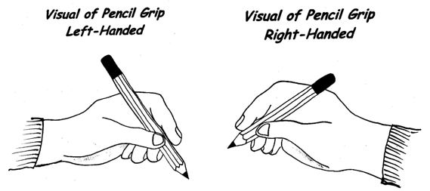

Letter Formation
Teach correct formation of letters:
C shaped: c o a g q d s f e
r shaped: r n m p h b k
Others: i j l t u v w x y z
(Important – All letters start at the top except ‘e’ and ‘d’ which start half way down.)

Letter Sounds
Learn correct pronunciation of letter sounds: https://www.spelfabet.com.au/2018/05/phonemes-are-sounds-and-articulatory-gestures/
Note that with half our letters we do not use our voice but just air passing through our mouth!

Correct Pronunciation of Consonants
Consonants are sounds where there is obstruction or "blocking" of the airflow caused by your lips (/m/), teeth (/θ/), tongue (/l/), palate (/ŋ/) or even deep down in your larynx (/h/). The two major categories of consonants are voiced and unvoiced consonants.
Voiced Consonants
Voiced consonants make sound using the vibration of your vocal folds in your larynx - the "voice box". You can tell if a consonant is voiced in a couple of ways:
1. Put your finger on your throat when you say it. If you feel vibration, it is voiced.
2. Put your fingers in your ears when you say it. If you can still "hear" the consonant through the vibrations in your neck and head, it is voiced.
Unvoiced consonants
Unvoiced consonants do not use this vibration. Instead they make sound using the movement of air through your teeth, tongue, lips and other articulators.

Voiced consonants | Unvoiced consonants
/b/ as in ball  /d/ as in dog  /g/ as in good  /j/ as in joke  /l/ as in love  /m/ as in mouth  /n/ as in no  /r/ as in right  /v/ as in van  /w/ as in window  /y/ as in you  /z/ as in zoo  /th/ as in that  /ng/ as in thing | /c/ as in cat  /f/ as in fat  /h/ as in he  /k/ as in kitten  /p/ as in pea  /q/ as in queen  /s/ as in see  /t/ as in tea  /ch/ as in cheap  /tch/ as in catch  /ck/ as in duck  /th/ as in thin  /sh/ as in she  /wh/ as in when
/ / = sound can be continued until you run out of breath!

Learning to Read
How the brain learns to read: https://www.youtube.com/watch?time_continue=3&v=wlYZBi_07vk&feature=emb_logo

Preventing literacy failure and shifting the whole Bell Curve up:
https://www.youtube.com/watch?v=mafVooDom8k&t=11s

Learn the letter sounds quickly: https://readingsimplified.com/learn-letter-sounds/

The 2 videos on the website below explain how to start teaching reading based on the Science of Reading The videos are a little long but, if you learn these basics, your child will make faster progress:
https://readingsimplified.com/learn-letter-sounds/

How to help your child read:
https://www.facebook.com/ReadingSimplified/videos/674150383334910
https://readingsimplified.com/blending-sounds-together/
https://www.youtube.com/watch?v=RPJ-rC_PcaU&feature=youtu.be&fbclid=IwAR2zg3ayvZE9drnuRpxn-NCPSmTSZQxgc53WnBskL-fEY6AKVd2qOYsMwEg

Free decodable books on-line:
https://portal.flyleafpublishing.com/learners-resources/
https://www.speld-sa.org.au/services/phonic-books.html
https://blog.allaboutlearningpress.com/decodable-books/

MATHS
Created by expert maths teacher, Pat Murray, MathsOnline is Australia's leading online maths tutoring program with teacher-led video tutorials and course content aligned to the Australian Curriculum.
Covering kindergarten right through to year 12, MathsOnline is ideal for catch up, for keeping up, and for moving ahead.

https://www.mathsonline.com.au/

GENERAL KNOWLEDGE

A list of free on-line resources to expand your child’s knowledge of the world:

https://www.readworks.org/

https://chatterpack.net/blogs/blog/list-of-online-resources-for-anyone-who-is-isolated-at-home

https://wonderopolis.org/

https://adventuresinfamilyhood.com/20-virtual-field-trips-to-take-with-your-kids.html

