cosy | going | hello
joking | only | pony
sofa | broke | close
drove | phone | smoke
spoke | blow | follow
hollow | lower | mower
rows | snow | snowy
float | groan | oats
oak | toad | toast
1 | 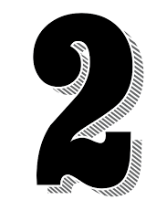 | 

