Only print pages 2 & 3!

A Note From Mim:
In November 2019, I saw an intriguing article online about a pigeon who was stealing poppies at the Australian War Memorial and also about the use of pigeons in war.

One of my students is the grandson of a pigeon fancier in my town, in South Australia. He often helps his Grandfather and is fairly knowledgeable about racing pigeons!

I thought he would like to see the article about the 'stolen poppies' but the language in it was too difficult for him as he’s a struggling reader. So I thought I would adapt the article for him, especially as it was Remembrance Day a couple of days later!

I simplified quite a few words and only extracted the most relevant information, as he needs words that are easily decodable. It was a bit of a challenge for him but my support, and his interest in the topic, propelled him through it!! :)

I hope your students enjoy it too!

LOOK FOR Sheryl Hunt’s story about the exploits of one particular pigeon, “Q879”, that was inspired by this article! You’ll find it in the ‘Documents’ section of the Australian Teachers’ Group on the Reading Simplified Academy!

Original article title: ‘Winged Warrior’, written by Claire Hunter, 6 November, 2019, Australian War Memorial.
https://www.awm.gov.au/articles/blog/pigeons-at-war (Used with permission.)

Simplified by Mim Blake for students of ‘Mim Blake Tutoring’. Find us on facebook!
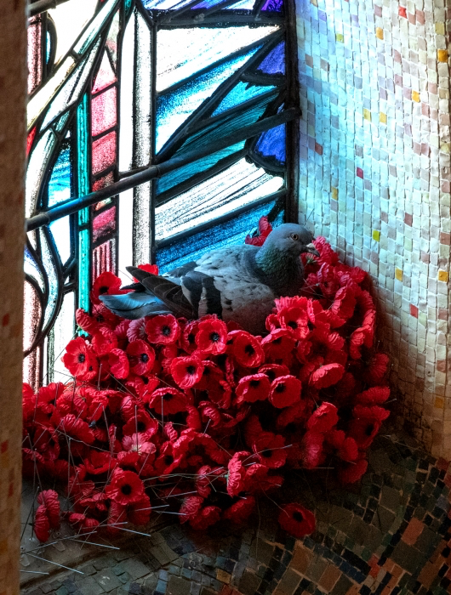
The Mystery Of The Stolen Poppies Solved!
In the peace and quiet of the Hall of Memory at the Australian War Memorial, a pigeon has been busy preparing for new life in a place that commemorates death and sacrifice.

Each day the pigeon has been flying down to the Tomb of the Unknown Australian Soldier to steal poppies, carefully crafting a nest above the stained-glass window of a wounded Australian soldier.

The nest of poppies is a moving reminder of the powerful bond between man and beast on the battlefield.

Pigeons have been used in war and civilian life for centuries.

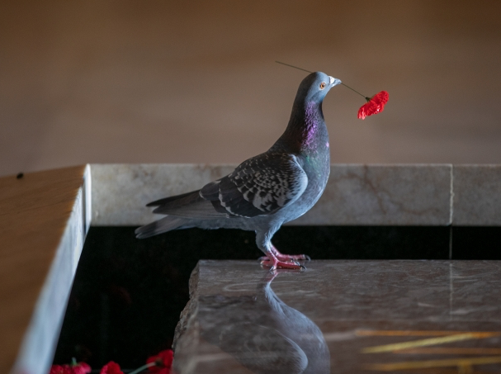
In war, animals perform tasks that people can’t do easily on their own. Thousands of pigeons were used in the Second World War. They were an answer to problems with communication. Telephone wires got broken in the shellfire on the Western Front. Mountains and humidity meant the wireless radios didn’t work very well, so pigeons were a better way of getting messages up and over the mountains on the islands in the Pacific. A pigeon often can get through when nothing else can.

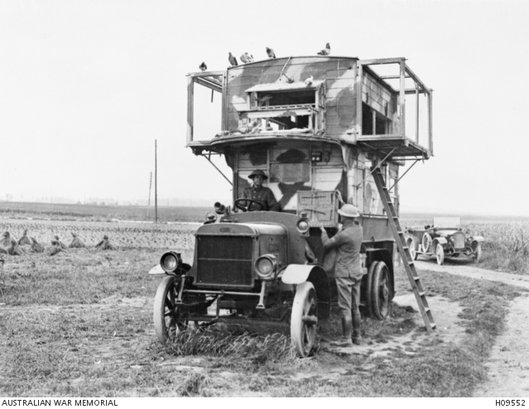
In 1942 a call went out to the pigeon breeders of Australia. A lot of men joined the army to become pigeon handlers. Pigeon breeders around Australia donated 13,500 trained pigeons to the army.
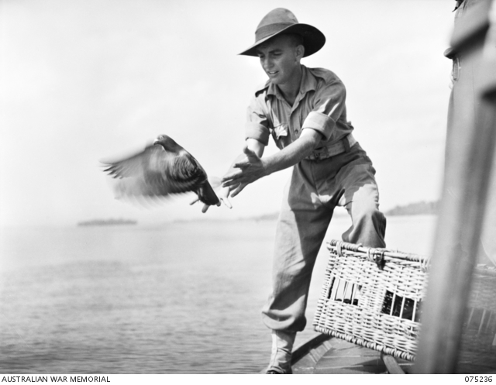
The Pigeon Units become so effective that Australia started teaching other armies, like the Americans, how to put a pigeon team together.

Medals
Two Australian pigeons were awarded a medal for their actions during the war. Medals were awarded to any animal showing great bravery and devotion to duty in wartime.

In 1944, a pigeon known as Q879, was sent to help some United States soldiers attempting to recapture Manus Island. A small group of soldiers headed off through thick jungle with a radio and a basket of pigeons, to investigate reports that enemy troops were preparing to attack them. As the Americans headed back to their base, they were spotted by the Japanese and a fight broke out. The soldiers needed help, but their radio would not work. One after another, the pigeons were released, with messages calling for help, rolled up in tiny canisters on their legs, but each pigeon was shot down by the Japanese troops. The Americans were surrounded by the enemy and knew that little Q879 was their last chance for rescue! He got back in very quick time with the message. He flew the 48 kilometres (30 miles) back to base in just 47 minutes and the men at the base were able to rescue the trapped soldiers.

In July 1945, another Australian pigeon, known as T139, was awarded a medal for carrying a message from a boat that was sinking, to the base in Papua New Guinea. The pigeon flew 65 kilometres (40 miles) in 50 minutes through a bad tropical storm. The boat, together with valuable cargo, ammunition and men, was saved!

There are lots of stories of pigeons bravely going out and saving people’s lives.

© ADAPTED by Mim Blake from an original article by the Australian War Memorial: ‘Winged Warrior’
Original article written by Claire Hunter, 6 November, 2019
https://www.awm.gov.au/articles/blog/pigeons-at-war (Used with permission.)

