The /i-e/ sound
An Australian text for students by Sheryl Hunt 2020

Q879
It was during World War Two that my life changed completely! I was content and living with my family under the care of Mr. Flavell, when one day I was taken on a journey to a place far, far away from my home.

Luckily I had some of my friends and family around me so I wasn’t scared or lonely, but we were all excited. We chatted amongst ourselves, wondering where we were going. When we raced on race days, the starting point was always the same but our destination was our own homes. Even though we were mates we were very competitive and each one of us longed to be first across the line when we raced.

Little did I realise then, how much we would be relied upon and how important our task would become. We held the lives of many people on our wings.
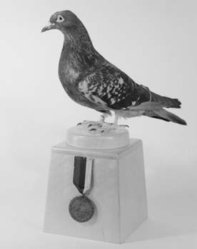
I was known as Q879 and was a proud member of the Australian Corps of Signals Pigeon Service. By now you may have guessed that I am a racing pigeon. We’re known for our speed in flying from one place to another to deliver messages.

My ancestors had flown in service during World War One and now I had the chance to serve my country too! I was excited but also wary about the dangers ahead.
https://www.rpra.org/pigeon-history/pigeons-in-war/

Continued…
2.
The Australian troops had a problem with radio communication. The islands in the Pacific Ocean had many high mountains and this meant that radio signals could not get through. The radio was silent. This was a nightmare situation for the soldiers facing the enemy. So my fellow pigeons and I helped to solve this problem.

I flew at high speed each time I went out because I knew how important my job was. Also I wanted to get back safely to my coop!

We became so good that our Aussie handlers trained soldiers from other countries on how to use racing pigeons in the war. That’s how I was assigned to the American troops and found myself in a very dire situation.

We were on Manus Island which was occupied by the Japanese. An American patrol had just checked the position of these enemy soldiers and was returning to base when they were spotted! Their radio no longer worked so it was up to us to get the message through to base for more fighting support.

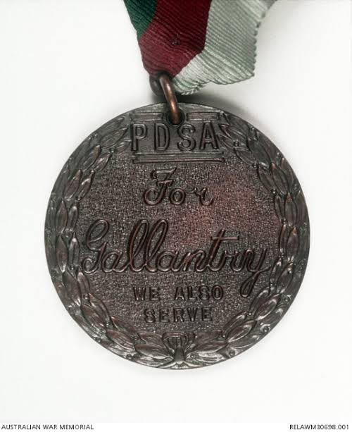
All around us shells were exploding! The noise and the smell of gunfire were terrifying. I watched as a message for help was put into a canister and strapped to the leg of the first pigeon and off he flew! But he was shot down! Then a second pigeon flew off, but again, he was shot down.

Image source: Dickin Medal : Pigeon Q879 awm.gov.au

Continued…
3.
It was now my turn. I have never flown so fast in my life! I flew 48 kilometres in 47 minutes! My message for help was successfully delivered and the American soldiers had support to defeat the enemy. I was very tired.
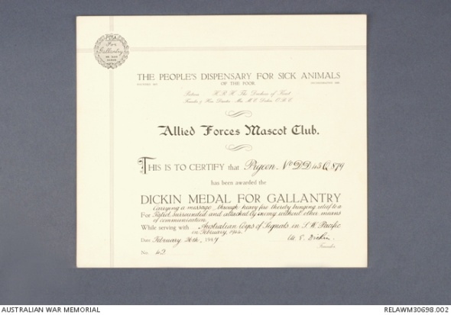
I survived the war. I returned to living a quiet life, my desire for excitement satisfied. In 1947, I was awarded the Dickin Medal for Gallantry, a special award given to animals who serve in war.

Image source: Dickin Medal Certificate : Pigeon Q879 awm.gov.au

Target sentence

I had to fly high in quick time or die.

I | y | igh
I | had to fly | high
i-e | ie
In quick time | or die

