cry | sky | shy
spy | try | type
why | behind | blind
child | kind | remind
unwind | wild | bright
fright | higher | highest
lightning | mighty | sunlight
fries | magpies | pies
untie | tries | dries
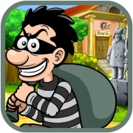 |  | 