babies | cookie | movie
pixie | relief | series
cheek | cheeky | greedy
sleepy | teeth | teeny
donkey | hockey | trolley
valley | easy | please
sneaky | scream | teach
teacher | treat | teapot
belief | sleep | really
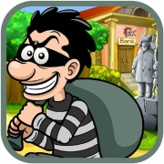 |  | 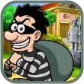  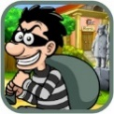  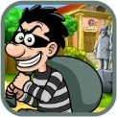
ie | ee | ey
ea

