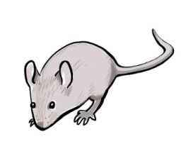

Clip art Mouse_illustration.jpg
The /aw/ sound
An Australian text for students by Sheryl Hunt 2019

Howard Florey and the importance
of eight mice

Howard Florey (1898-1968) was born in Adelaide and then attended St Peter’s College followed by Adelaide University where he studied medicine. He was an exceptional student who later won the South Australian Rhodes Scholarship. This took him to Oxford University to further his study in pathology.

Up until the 1940’s, something as insignificant as a scratch or a small cut could lead to a person dying from infection. This became the foundation of Florey’s interest.

Just by pure chance in 1928, another doctor, Alexander Fleming, had made a surprising discovery! He noticed that some mould which had fallen onto an experiment containing infectious bacteria had caused it all to disappear. Fleming called this new antibiotic “penicillin.” However, he was unable to extract the bacteria killing substance from the mould, so he moved onto different research.

Ten years later and Florey and his team of scientists chanced upon this study of penicillin and decided to find out how it could be used to fight disease. Florey knew that only a team working together would have success. He had the ability to inspire and motivate those around him. This was very important as his team worked with little funding and in cramped conditions. It was exhausting work which needed to be precise and carefully monitored.

Continued…
2

Before this antibiotic called penicillin could be used on people, it had to be tested. And this is where the story of eight mice becomes important. An animal so small but which held the key for success.

One day in 1940, eight mice were infected with deadly infectious bacteria. Then, four mice were injected with penicillin and the other four weren’t. These mice were the control group in the experiment.

Imagine walking into the laboratory the next day to find four healthy mice! What an awesome discovery!

Just three years later, Florey travelled to North Africa to treat soldiers who had been wounded in the fighting of WW2. The results were miraculous! The penicillin fought the infection in their wounds so that the soldiers didn’t need to have a limb amputated or die from infectious bacteria.

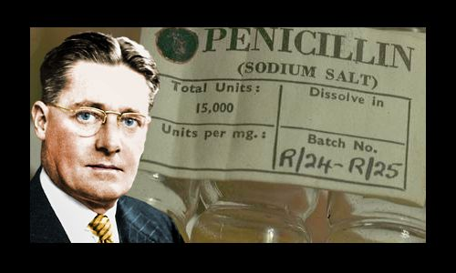

Image from https://www.famousscientists.org/howard-florey/

Continued…

3
This was not only a momentous turning point for the Allied soldiers at war then, but also for people around the world in the years since. No longer would adults and children suffer from the awful, often deadly consequences of a simple cut, injury or disease. In 1945, Howard Florey and his team won the Novel Prize for Medicine for their development of penicillin to fight germs and save lives.

Howard Florey, a humble but brilliant man.

Key sentence
The awesome talk in the audience as Florey thought the bacteria was caught!

aw | al | au
The awesome | talk in the | audience
or | ough | augh
as Florey | thought the bacteria | was caught!

The study of disease
Micro organisms which cause disease
A substance capable of destroying bacteria
To take out

