The /oo/ sound
An Australian text for students by Sheryl Hunt, 2019

(pronounced oo/lu/roo)

Uluru is the traditional name given to a massive sandstone monolith in the Northern Territory, Australia. It stands 348 metres high and the circumference of its base measures 9.4 kilometres. Uluru is believed to be around 600 million years old. One fact that is too surprising to be true is that approximately 2.5 kilometres of the bulk of Uluru is underground!

Another fact is that it is the second largest monolith in the world. The largest is Mount Augustus in Western Australia. Who knew Australia had the two largest!

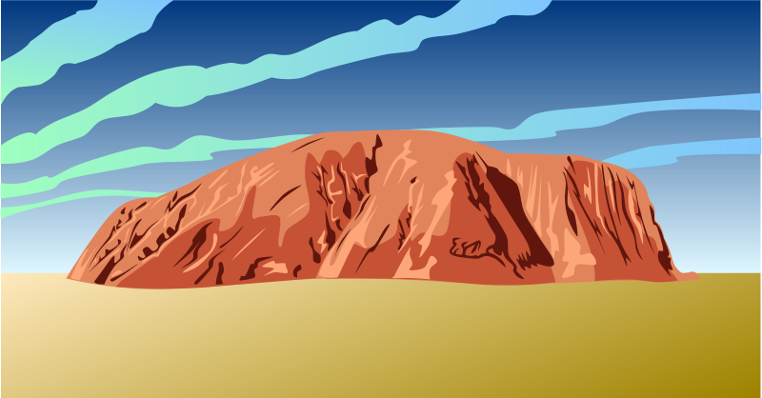
The huge monolith was first seen by a European explorer in 1873. His name was William Gosse and he named it Ayers Rock after Sir Henry Ayers who was an important businessman and politician in South Australia. The name changed to Uluru in 1977 in recognition of the traditional owners.

The Anungu (pronounced arn-ung-oo) people are the traditional owners of Uluru and the surrounding area. Aboriginal people have been on this land in Central Australia for around 30,000 years. Archaeologists have found evidence of this through the discovery of tools and ancient drawings found on rock surfaces.

(Ayers Rock (Australia) Free Clip art by Gerald_G License: CC0 1.0 Universal (CC0 1.0))
Continued…
2.

Today when people visit Uluru, they can participate in some traditional cultural experiences. It is important for the Anungu people that their traditional way of life, their stories and law are passed onto future generations. Their land is a school for others to learn from and to respect. Through living in a harsh environment like this, men, women and children knew how to survive and find food, water, shelter and medicine. This is the knowledge that is passed from generation to generation.

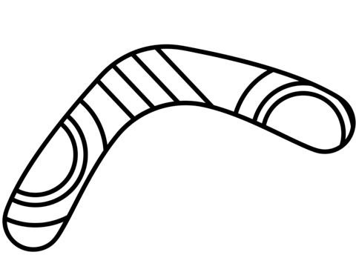
Over time and due to the harshness of the land, the Anungu people learnt how to use the plants and animals to their advantage. For example, the hard wood of the Mulga tree not only provided them with food, like mulga seeds and mulga apples, but also wood to make tools like digging sticks. The women and children used these to dig for food. Other tools like spear throwers, spear heads, barbs and boomerangs were used by the men to hunt for food.

A traditional diet is a balanced one as it includes food from each section of the food pyramid. So when the early European explorers were trekking across Australia, many of their lives may have been saved if they knew of the abundance of food around them.

In the language of the Anungu, maku (pronounced mah-koo) means edible grubs, such as witchetty grubs. These grubs are found in the roots of trees and are an important source of protein. Kuka (pronounced kooka) means edible animals, such as sand goanna, emu, woma python, kangaroo and the eggs of birds and lizards.

http://www.supercoloring.com/coloring-pages/boomerang
Categories: Australia Original image credit: Marks designes by Outstandy for Wikipedia 15 anniversary Permission: Public domain
Continued…
3.

Visitors are no longer able to climb “the rock” as a mark of respect to the traditional owners. However, Uluru will still be an awesome sight, looming out of the desert, growing bigger and bigger as travellers approach, in its striking orange and red.

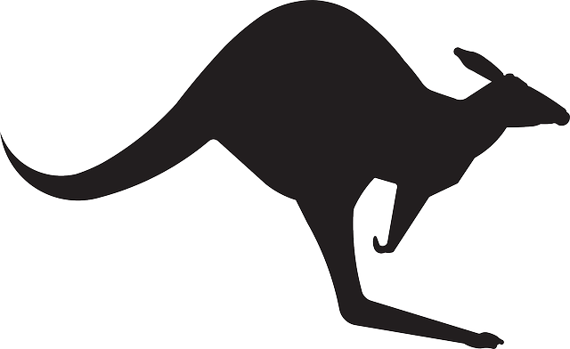

Free clip art image
https://www.istockphoto.com/au/illustrations/kangaroo

Key sentence
Who knew a boomerang could fly true through the air to hit a canoe!

o | ew | oo | ue
Who | knew | a boomerang | could fly true
ough | oe | u
through the air | to hit a canoe! | Bonus spelling

A single, huge block of stone
Information given to establish a fact
Plenty, more than enough
Fit to be eaten

