This is my own personal list. I often keep a list to remind me of the games and resources that have worked well with students. With so many resources available online, I find that I do and have become easily overwhelmed, and distracted. In the past, I have exhausted myself “surfing the net” for the “next best thing for teaching reading”. I still enjoy searching, but since Reading Simplified I do far less searching online and have more time for tutoring. Keeping all learning activities closely aligned with the Reading Simplified core activities keeps me focused on what is most important for beginning and struggling readers. Students love variety and so do I!

I normally just make a list and do not include the website or source but since I was sharing this online with the RS academy it was right to give credit where due and allow for copyright.

Teachers are very creative and I am sure you all have heaps of great ideas to share! I hope this helps a little.

All the Best
Candace

Switch It Compatible Games

Switch It (Reading Simplified) is pretty perfect but for variety the following:

1. Making the switch by erasing and writing the letter.

2. Little Learners Love Literacy “Phonemic Fun Add/Delete A Sound”.

3. Monster Head, Body and Tail Change it.
https://bogglesworldesl.com/phonics_monsters.htm
https://bogglesworldesl.com/phonics_changeit.htm

4. DIY Word Making Flip Chart

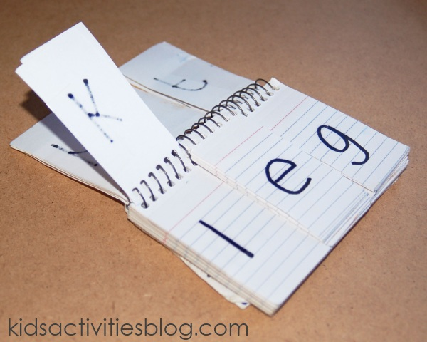

Divide the phonics flip chart into three sections for three letter words, but it can be split into four sections to help an early reader work on consonant blends.
After you cut the number of sections that you want, label each card with a letter (a-z). We added another section of vowels in the center section and several common blends on the ends (ex: ch, sh, th, gr, cl, etc.).
The point of the phonics flip chart is not so much to “spell” words, but to practice sounding out words.

Reinforce the top of your cards they start to tear along the perforation.

Read It Compatible Games

1. Build A Tower: I adapt this for the word patterns I am teaching.
https://readingmadesimple.weebly.com/uploads/6/8/7/5/68750791/oo_build_a_tower_game.pdf

2. Bump https://thisreadingmama.com/word-bump-spelling-games/

3. A whole bunch of card games to make at: https://www.kellyskindergarten.com/Games/GamestoMake/games_to_make.htm

4. Steal I: Besides the playing the traditional Steal It game, I try and repurpose the Reading Simplified Steal It word cards in other games.

5. Crazy Shorts and Crazy Longs https://www.soundreaders.com/online-store

6. Trugs Sets (Not sure this is available in USA. I bought all three box sets. It's pricey but I love them!)
http://www.store.dsf.net.au/Trugs

7. Spelfabet Cards Games https://www.spelfabet.com.au/materials/

8. Bingo

9. CandyLand: I have my students read the words and then write the word. In my version of Candyland there are two winners the one who reaches the gingerbread house and the one with the most words on their list.

10. Snakes and Ladders

Read It/Write It Compatible Games

1. Candy Land with Reading Simplified Cards with a writing component or use the blank coloured Candy Land cards with a specific words cvc ccvc etc. The blank coloured cards indicate how many word cards need to be picked up, read and written.

2. Snakes and Ladders with Reading Simplified Cards with a writing component. Blank Snakes and Ladders laminated game board that words can be written on and changed as needed.

3. Read, Tap, Map and Write: a la Mim Blake (Mim Blake Tutoring @minblaketutoring on facebook.
or Melinda Crean from Top Notch Teaching https://topnotchteaching.com

4. Spelfabet WorkSheets https://www.spelfabet.com.au/product-category/workbooks/

5. Any Generic Board Games that where students read and write word/phrases/sentences. Use your premade word cards for the pattern being taught and practiced.

Sort It Compatible Games

1. Sort It is pretty great as it is but for variety and especially if a child has handwriting challenges, use word cards to read, highlight code and sort under correct heading.

2. Top Notch Teaching Long Vowels Pack
https://topnotchteaching.com/downloads/long-vowels/

