my | by | try
sky | dry | fly
time | like | bike
ride | five | slide
night | light | sight
high | fight | might
find | kind | child
wild | climb | white
pie | tie | die
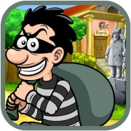 |  | 