don’t | open | most
only | both | over
home | woke | drove
hose | those | close
show | know | grow
own | snow | slow
boat | road | coast
goat | soap | coat
toe | hoe | Joe
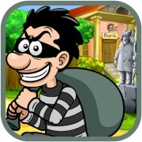 |  | 