Manual Mania
On the one hand, I was excited as a kid in a candy store after downloading the Reading Simplified Complete Manuals at the end of the Main Course. On the other hand, I had no idea what to choose (especially for Guided Reading).
After much perusal, I discovered that the Grades 2-3 Manual and Grades 4-5 Manual are nicely chunked and labeled with title pages. (I have yet to combine them and identify duplicates; nevertheless, the chunks are perfectly labeled by title pages.) The chunks are not in the order of the Streamlined Pathways.
By the way, Deb Plotczik created a handwritten pdf Table of Contents. Esther Schmeer Greenfield went on to create a Google Doc with Tables of Contents for all of the manuals. You will find these lifesavers by going to:
Facebook Reading Simplified Academy Group
Search (little magnifying glass): Table of Contents
The PK/K and First Grade Manuals, I literally chunked: printed out all the pages, sorted them, and took out duplicates. Then I put all the chunks in one big binder in the order of the Streamlined Pathways. So, I have a new Table of Contents for my:
Reading Simplified PK/K and First Grade Manuals Combined
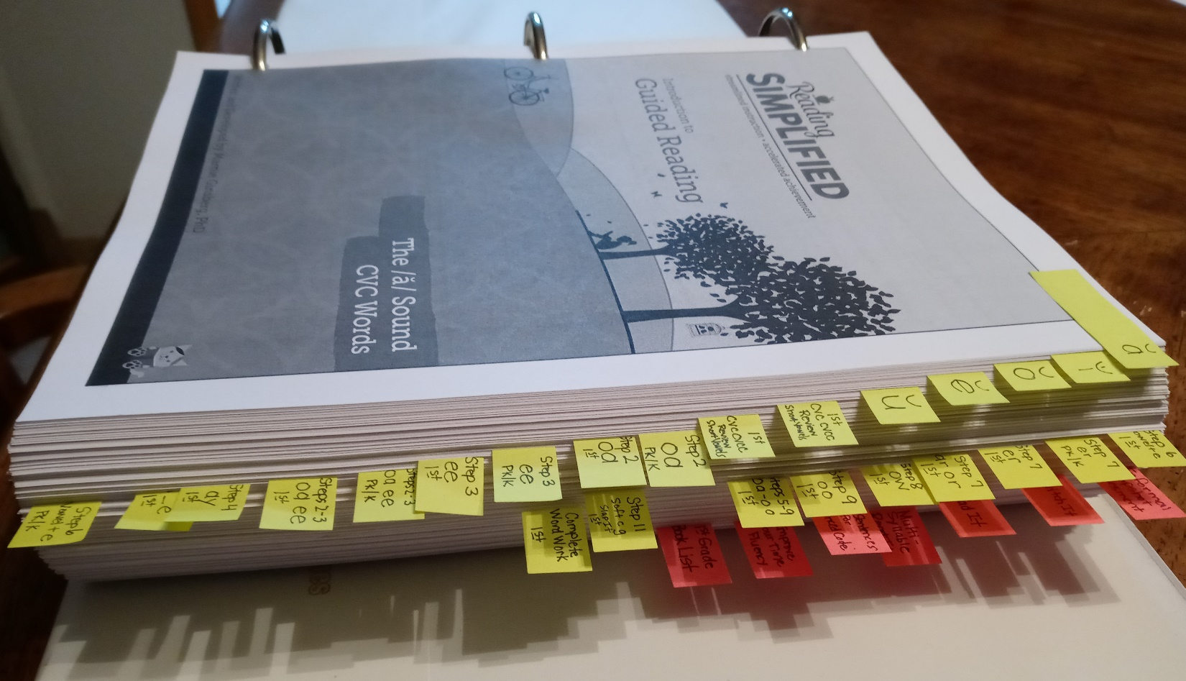
- Yellow-Green Tabs: phonemes*
- Pink Tabs:
  - Informal Snapshot Assessment
  - Switch It
  - Read It
  - Multi-Syllable Read It
  - Key Sentences for Advanced Code
  - Improve Your Fluency
  - First Grade Book List
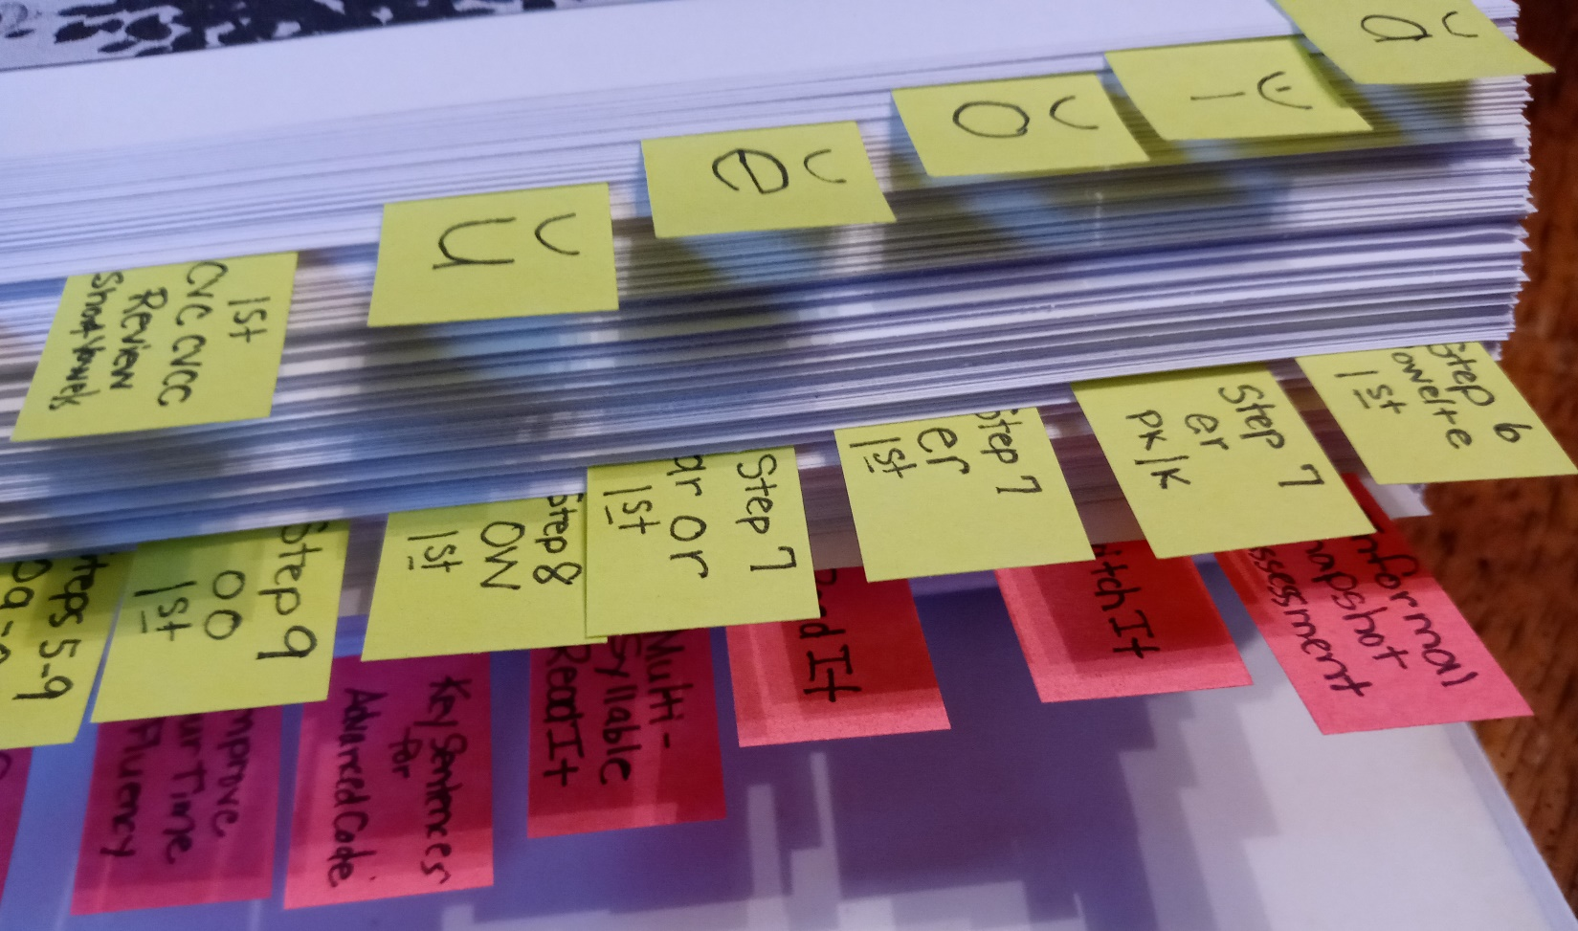

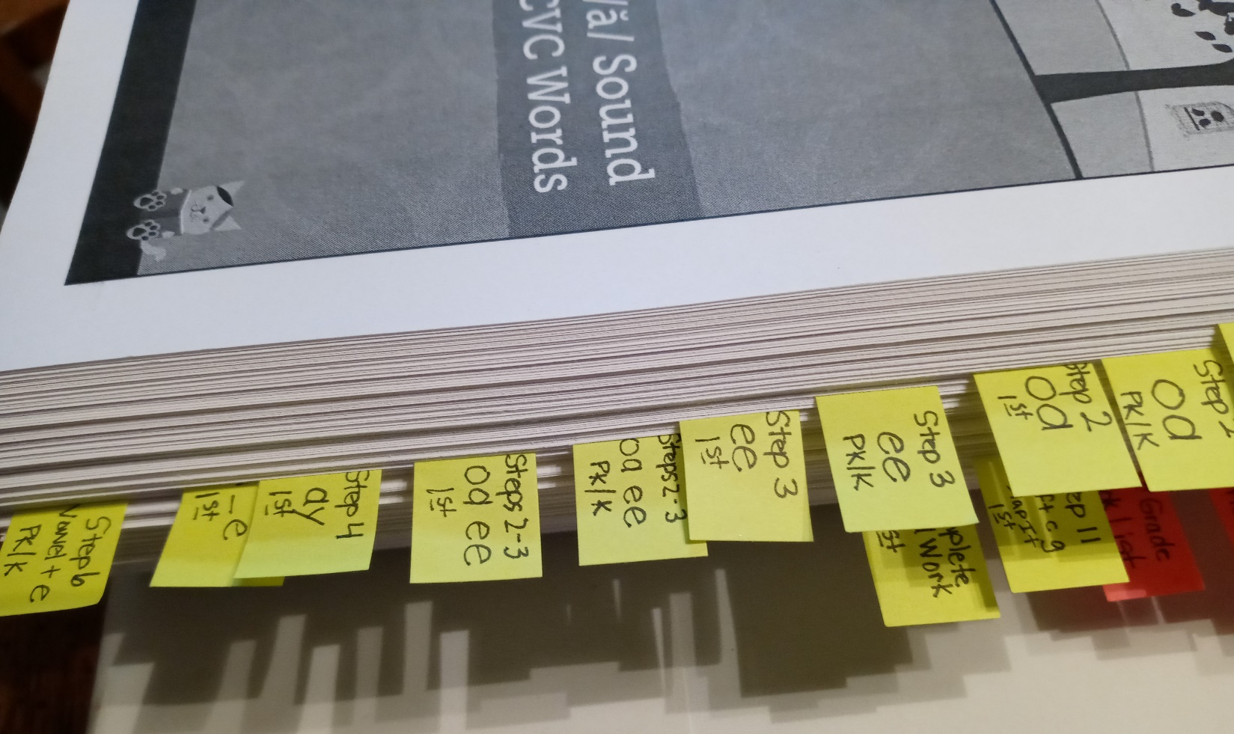

*Here’s how the phonemes turned out:
- ă
- ĭ
- ŏ
- ĕ
- ŭ
- 1st CVC CVCC Review Short Vowels
- 1st CVC CVCC Review Short Vowels (different)
- Step 2 oa PK/K
- Step 2 oa 1st
- Step 3 ee PK/K
- Step 3 ee 1st
- Steps 2-3 oa ee PK/K
- Steps 2-3 oa ee 1st
- Step 4 ay 1st
- Step 5 i_e 1st
- Step 6 Vowel+e PK/K
- Step 6 Vowel+e 1st
- Step 7 er PK/K
- Step 7 er 1st
- Step 7 ar or 1st
- Step 8 ow 1st
- Step 9 oo 1st
- Steps 5-9 oa – oo 1st
- Step 11 soft c g Slap It 1st
- Complete Word Work 1st

- At the back of the binder: Duplicates between PK/K & First Grade Manuals (102 pages):
- Informal Snapshot Assessment (6 pages)
- Template with Letter Tiles (3 pages)
- Switch It Directions (1 page – PK/K & First Grade have different pages; one page overlaps - rich to which)
- Switch It Word Lists (22 pages)
- Read It Word Lists (2 pages)
- Read It Word Cards (45 pages; first word is at; last word is scrimp)
- /oa/ by different titles:
  - PK/K Introduction to Sort It – The /oa/ Sound (5 pages)
  - First Grade Introduction to Advanced Phonics – The /oa/ Sound (5 pages)
    - Pull “Row, Row, Row Your Boat” from First to add to PK/K
- Advanced Phonics Templates with Key Sentences but no words (9 pages, numbered 1-9)
- Key Sentences for Learning Advanced Phonics page with all the sentences (1 page)
- Improve Your Time (1 page)
- Race to the Finish (1 page)
- Make Your Way Back to Earth! (1 page)

