had | ran | sat
tap | dam | yes
red | pet | fed
wet | bit | sip
dig | fix | win
not | rob | top
rod | jog | run
hut | mud | bus
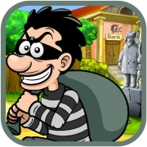 |  | 