Parent Work to Support Students at Home

For the Simple Code I send parents home with a magnetic board of letters and the Switch It Word Lists, a small whiteboard, whiteboard marker and duster for Write It and a relevant decodable book or 2 for Read It. Remember parents have first seen me model how to use these materials!

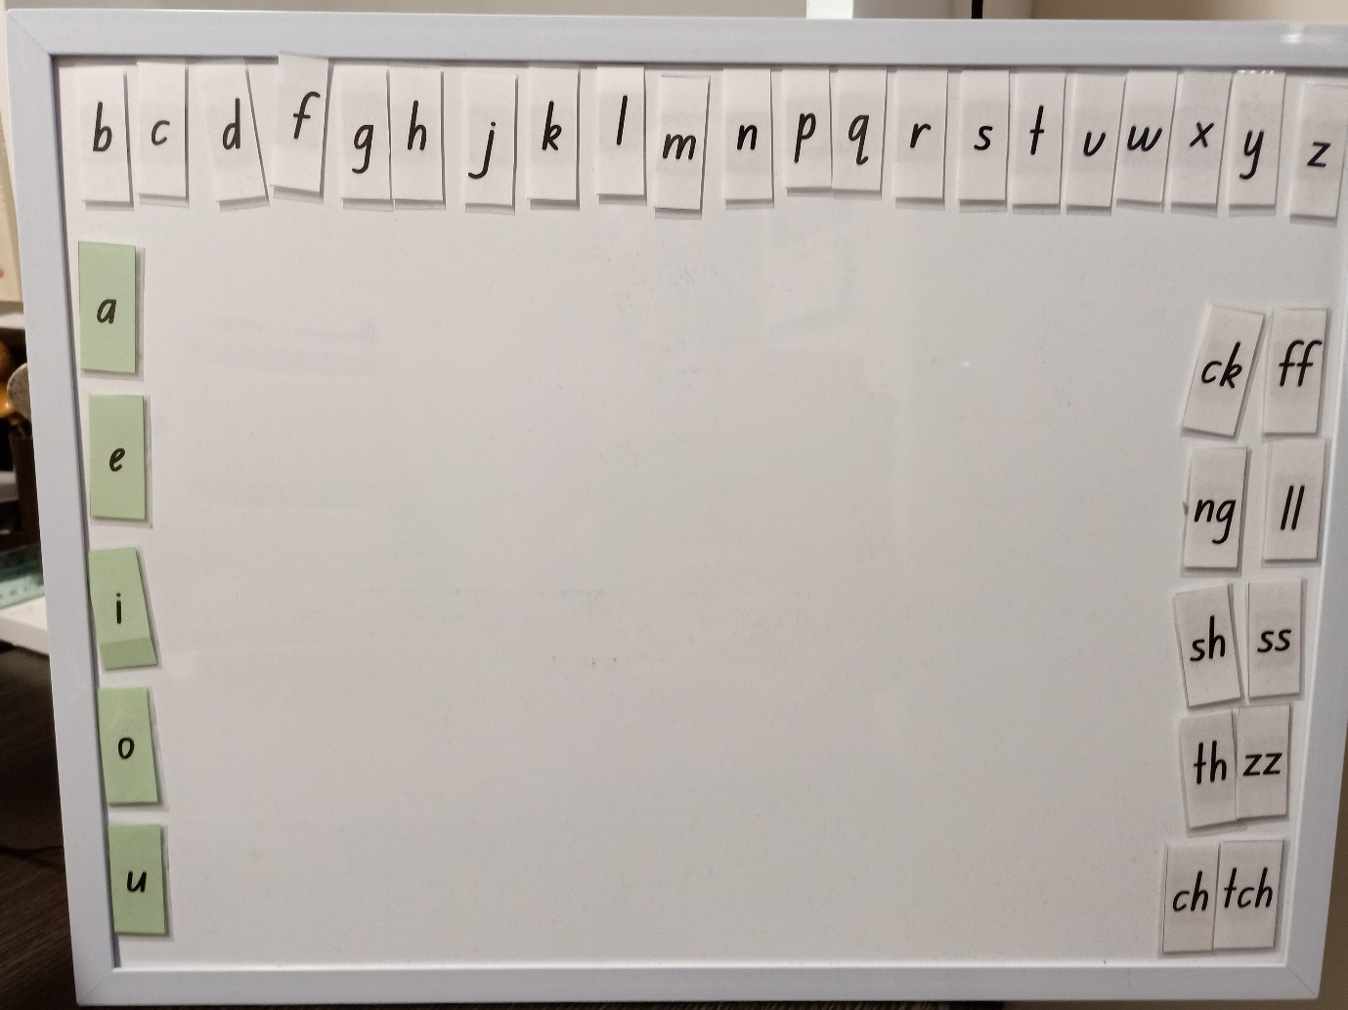

For the Advanced Code I send parents home with a folder containing a card containing the focus sentence, individual sound cards, flashcards containing the relevant common one syllable words for Sort It, a recording page for Write It, relevant decodable books for Read It and the Steal It Game for FUN! Remember Parents have first seen me model how to use these materials!
