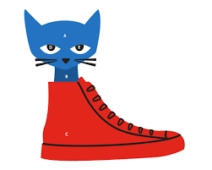
Sort It The /oo/ sound

KEY SENTENCE: I love to scoot in my new, blue shoes to judo!
Sort It List
chewing
altogether
smoothly
humour
spoon
renew
improve
approval
who’s
shampoo
avenue
Andrew
cartoon
fortune
canoe
statue
loop
crusade

o | oo | ew
I love to | scoot | in my new
ue | oe | u
blue | shoes | to judo!



Based on the work of Marnie Ginsburg, Reading Simplified.

