play | day | way
away | stay | may
came | ate | made
cake | gave | make
again | wait | main
rain | train | paint
clay | spray | chase
they | grey | game
able | baby | lady
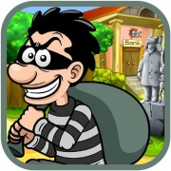 |  | 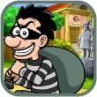  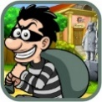  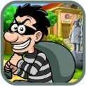

ey | a_e | ay
ai | a

