car | farm | park
start | party | garden
dark | star | art
past | after | craft
ask | father | basket
last | can’t | grass
path | fast | palm
calm | half | calf
aunt | laugh | heart
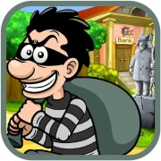 |  | 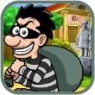  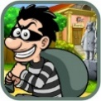  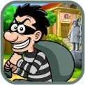

ar  farm | a  mask | al  half
au  laugh | ear  heart | are  are

