also | almost | always
alright | small | stall
born | sport | short
fork | north | storm
saw | prawn | yawn
claw | draw | lawn
Paul | haunt | autumn
August | author | chalk
talk | walk | stalk
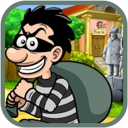 |  | 