he | she | me
be | even | we
week | three | tree
sleep | green | keep
really | eat | beach
read | teacher | team
funny | happy | silly
many | baby | party
these | please | been
 |  | 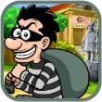  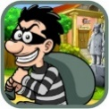  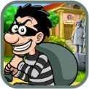

e | ee | y
e_e | ea | ear

