boil | noise | coin
join | point | soil
boy | boys | toy
toys | joy | enjoy
house | mouse | round
ground | found | shout
down | how | now
town | brown | clown
flour | spoil | flower
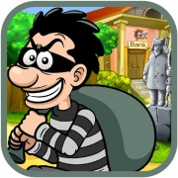 |  | 