book | cook | foot
good | hook | look
took | wood | wool
shook | stood | put
pull | full | bush
push | bull | helpful
could | would | should
couldn’t | wouldn’t | shouldn’t
wolf | wolves | woman
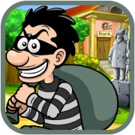 |  | 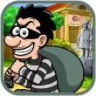  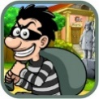  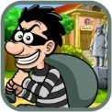

oo | u
o | oul

