has | can | bad
cat | man | get
bed | pen | leg
vet | did | him
big | sit | tin
got | dog | hop
box | job | but
fun | cut | hug
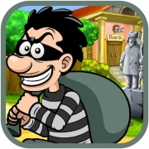 |  | 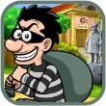

a | e
i | o
u

