bag | cab | fan
mat | van | led
let | met | ten
yet | fit | mix
hit | pig | bin
cot | log | hot
pot | lot | cup
bun | jug | sun
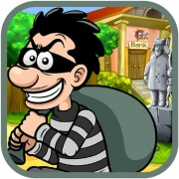 |  | 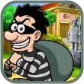

a | e
i | o
u

