lamp | band | pant
damp | land | rest
went | held | tent
mend | gift | sink
mist | fist | limp
sold | bond | cost
soft | just | gust
junk | hunt | gulp
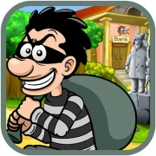 |  | 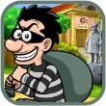

a | e
i | o
u

