deck | rock | luck
duck | pick | shed
ship | rush | cash
shop | thud | this
that | then | rich
chip | much | chat
witch | long | sing
song | ring | bang
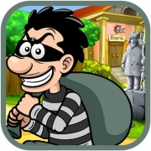 |  | 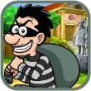

ck | sh
th | ch
ng

